Nathan Bemus

Corey McLaughlin

Alex Lang

ATM Machine UML

Activity UML

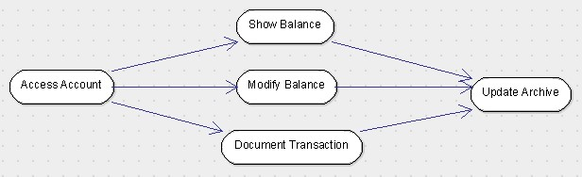

Class UML

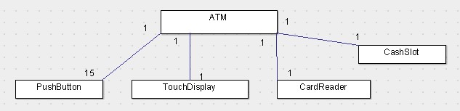

Interaction UML

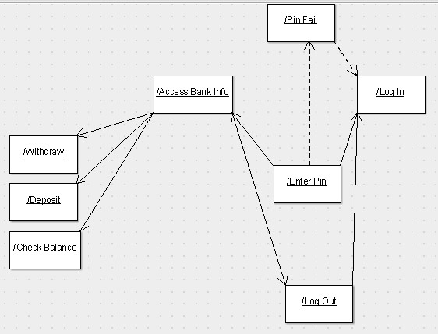

State Machine

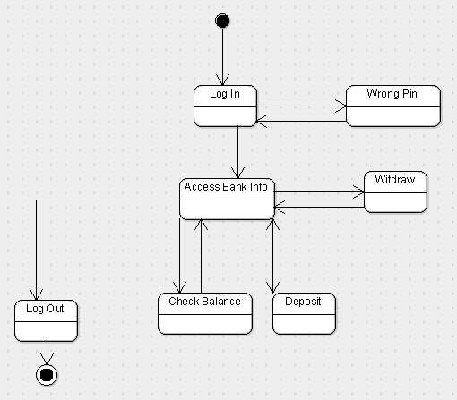

Use Case UML

